

GEN AI PROJECT SUBMISSION DOCUMENT

1. **Project Title:**

**Resume Generator AI**

1. **Summary of Work Done**

## Proposal and Idea Submission:

In this phase, we identified the challenge of automating resume creation and proposed a solution using **Generative AI models via Hugging Face**. The goal was to build a tool that generates well-structured, professional resumes based on user inputs such as personal details, experience, and education.

**Objectives:**

* Understand the capabilities of transformer-based text generation models.
* Use Hugging Face pre-trained models to create content sections for resumes.
* Design a web-based interface to collect user input and display generated resumes.

A detailed project proposal was submitted with the problem definition, objectives, tools, technologies (Hugging Face Transformers, Python, Stream lit, and expected output format.

## Execution and Demonstration:

The proposed system was implemented using **Python**, **Hugging Face Transformers**, and **Stream lit**.

**Key Features Implemented:**

* Developed a user-friendly interface to take inputs like name, skills, education, experience, etc.
* Integrated Hugging Face’s pre-trained language models (e.g., GPT-2, T5) to generate personalized content for sections such as summary, skills, and job descriptions.
* Automatically arranged the content into a resume-like format with proper structure and styling.
* Allowed users to download or copy the resume content.

Sample resume generations were saved and submitted along with the full source code.

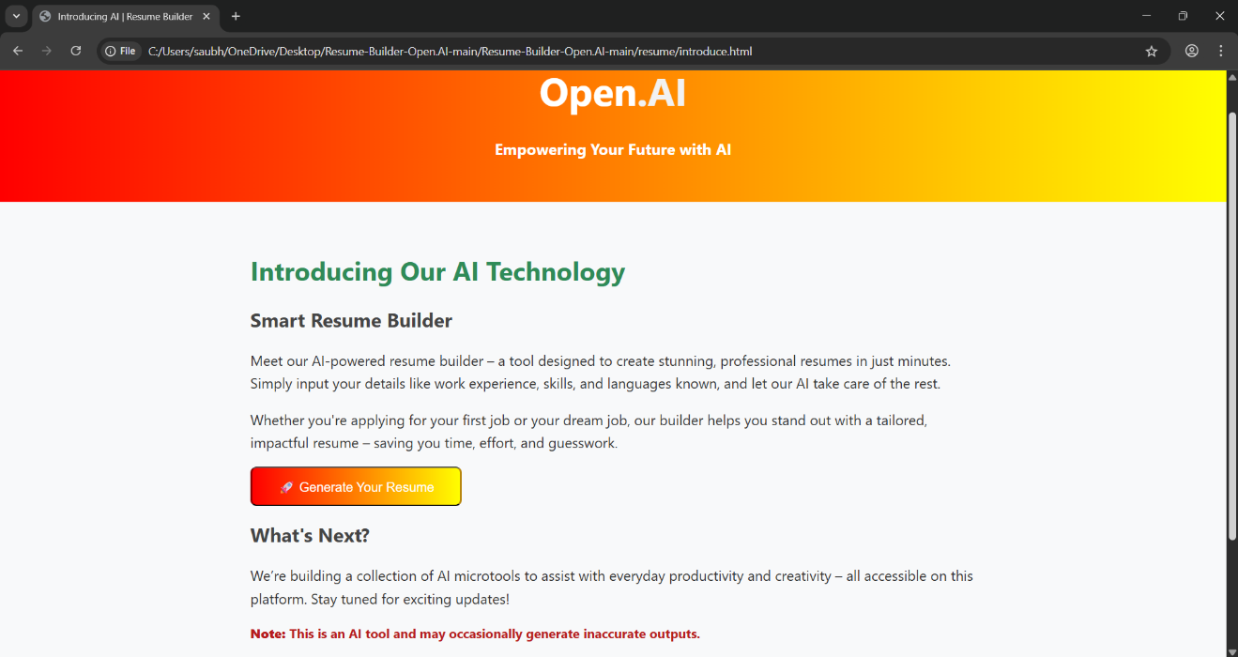

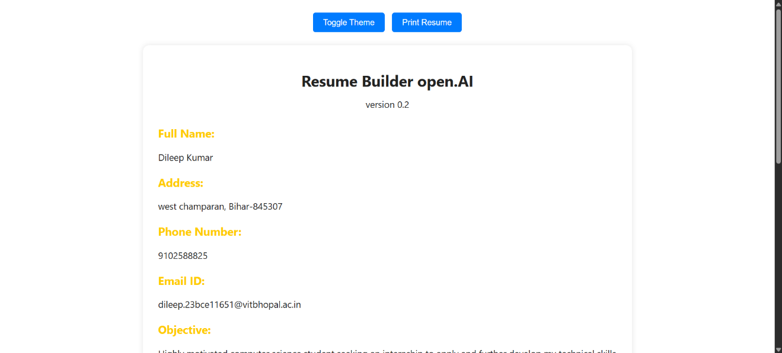

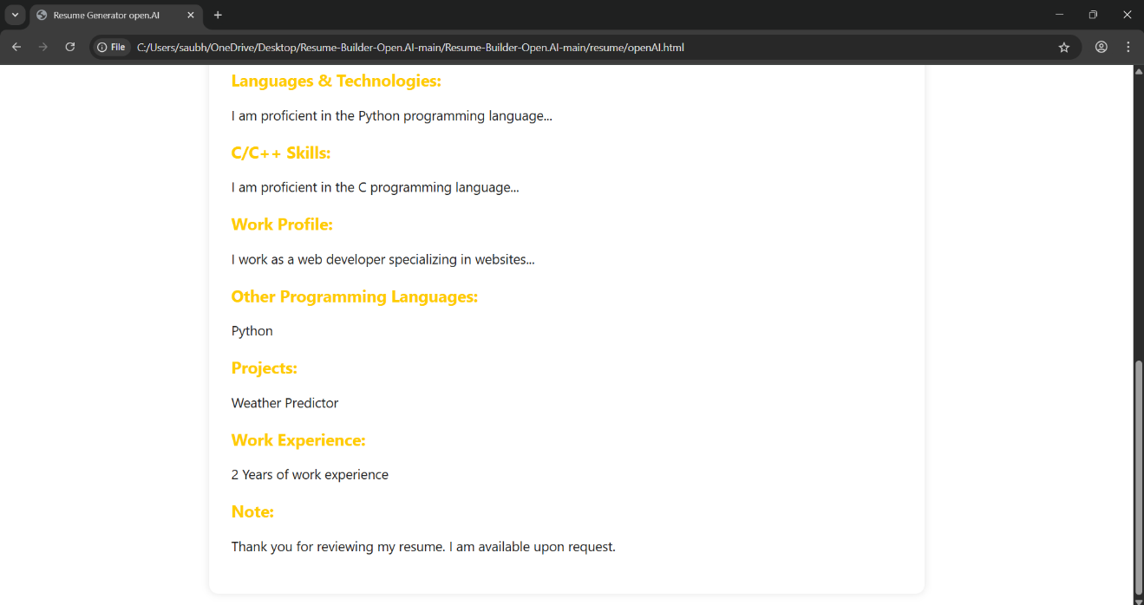

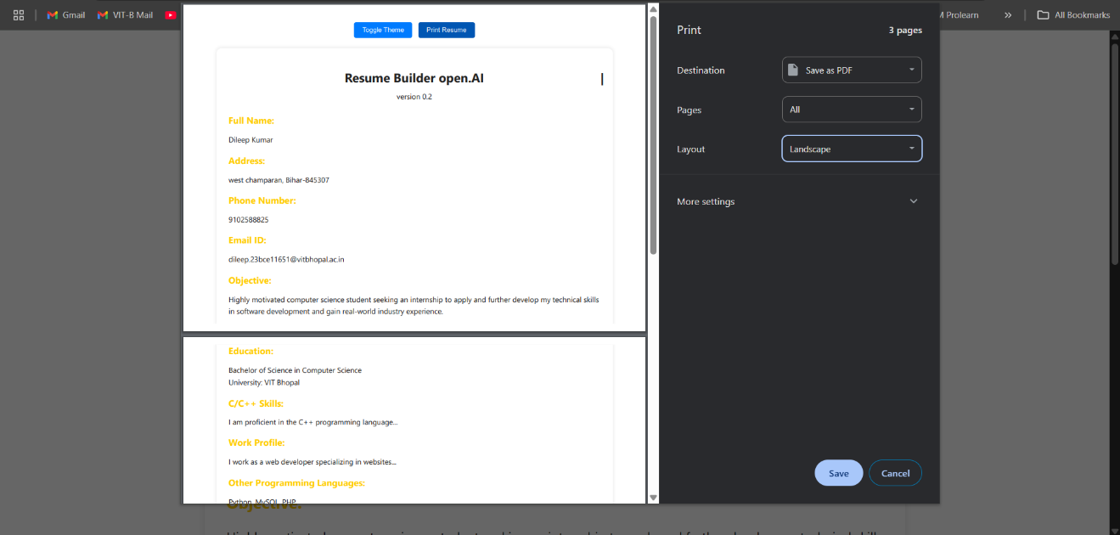



# GitHub Repository Link

You can access the complete codebase, README instructions, and any related resources at the following GitHub link:

*https://github.com/Dileepkumar91025/gen-ai*

# Testing Phase

## Testing Strategy

The system was tested through multiple approaches to ensure performance and content quality.

* **Input Handling:** Tested with varied user profiles—freshers, experienced professionals, different industries.
* **Content Quality:** Verified grammatical correctness and coherence of generated sections.
* **Edge Case Testing:** Inputs with missing or very minimal data were used to test model fallback behaviour.
  1. ***Types of Testing Conducted***

# Unit Testing

* + Each component (input forms, text generation logic, formatting functions) was individually tested.

# Integration Testing

* + Tested the complete flow-from input to resume display.

# User Testing

* + A Multiple users tested the system to validate usability and usefulness.

# Performance Testing

* + The Endure generation time was within acceptable limits



## Results

* + - **Accuracy**: The generated resumes were mostly accurate, with contextually appropriate summaries and skill lists.
    - **Speed**: Resume content was generated within 2–3 seconds of user input submission.
    - **Robustness**: The model handled edge cases gracefully and returned general suggestions when inputs were insufficient.

# Future Work

While the project successfully implemented but there are several avenues for future enhancement:

# Model Fine-tuning

* + Add multiple professional resume formats with theme and layout switching.

# PDF Generation

* + Automatically convert generated resume to downloadable PDF.

# Fine-tuned Resume Models

* + Train or fine-tune models specifically on resume datasets for improved output

# User LinkedIn Integration

* + Fetch user data from LinkedIn API to auto-fill resume sections.

# Expansion to Multi-Language Support

* + Extending the model’s capability to generate predictions in multiple languages, making the application useful in a global context. Pre-trained models in different languages or multilingual models could be utilized for this purpose.

# Conclusion

This project successfully demonstrated how **Generative AI and NLP models** from Hugging Face can automate and personalize resume creation. The system shows how AI can enhance productivity tools by generating coherent, relevant, and structured text based on user input. Through all phases, from planning to deployment, the project highlighted practical applications of transformer-based models in everyday tasks like resume writing.



And models can be applied to real-world NLP tasks, such as sentence prediction, writing assistance, and chatbot development.